Lab 1: Self-Healing & Scaling
Kubernetes Fundamentals — Hour 1 Practical Assignment

Scenario
Your team lead asks you to prove that Kubernetes can keep a simple web application alive no matter what is thrown at it, and that it can run multiple copies of that application simultaneously. Before connecting a database or an API layer, the team wants confidence in the underlying self-healing and scaling behavior.

Learning Objectives
- Deploy a multi-replica application using a Deployment manifest
- Observe how Kubernetes responds when a Pod is deleted
- Scale a running Deployment imperatively, without editing YAML
- Read and interpret kubectl describe output for a Deployment

Prerequisites
- Docker Desktop with Kubernetes enabled (kind or Kubeadm, single node)
- kubectl confirmed working: kubectl get nodes shows a Ready node

Instructions

Step 1 — Write the manifest
Create a file named lab1-nginx.yaml containing a Deployment and a Service. The Deployment must run the nginx image with 3 replicas. The Service must expose port 80 and route to the Deployment's Pods.
Think before you write
What label will the Service use to find the right Pods?
Where does replica count belong in the manifest?

Step 2 — Deploy and verify
- Apply the manifest to the cluster.
- Confirm all 3 Pods reach the Running state.
- Confirm the Service was created with a ClusterIP.

Step 3 — Break it on purpose
- List the running Pods and note their exact names.
- Delete exactly one of the three Pods.
- Immediately list the Pods again.
- Record what changed: pod name, age, and total count.

Step 4 — Scale without touching the YAML file
- Find the kubectl command that changes replica count directly from the command line, without re-applying any file.
- Use it to scale the Deployment from 3 replicas to 5.
- List the Pods again and confirm 5 are now running.

Step 5 — Read the Deployment's own report
- Run the describe command against the Deployment (not a Pod).
- Locate the field that shows current replica count versus desired replica count.
- Locate the Events section and note the most recent scaling event.

Your Answers
Fill in what you actually ran and observed. One or two sentences per item is enough.

Command used to deploy the manifest
kubectl apply -f lab1-nginx.yaml

What happened immediately after deleting one Pod, and why
Self Healing concept used, pod counts remain same, one deleted and new pod generated

Command used to scale from 3 to 5 replicas
kubectl scale deployment nginx-demo --replicas=5
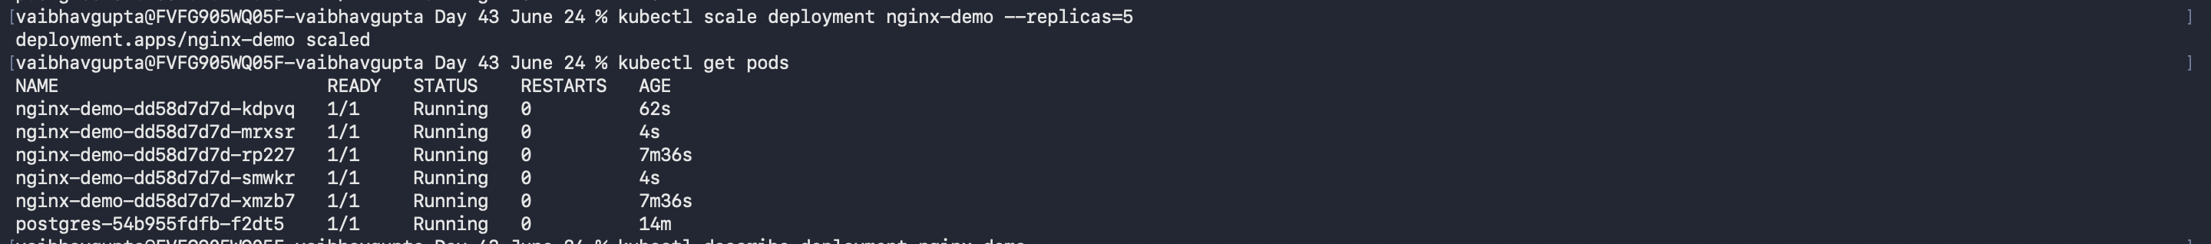

Where current vs. desired replica count appears in describe output
In Replicas
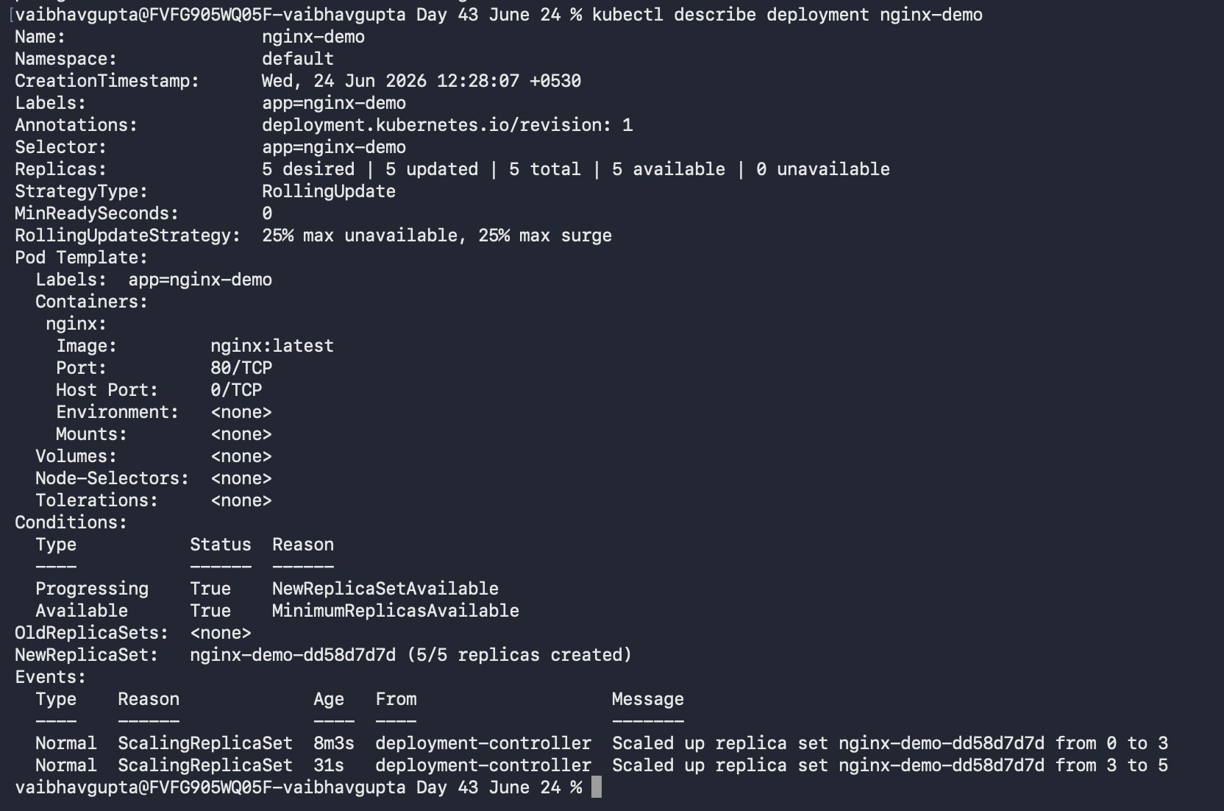

Solution
Before you read on
Only continue once you've attempted Steps 1–5 yourself, or are genuinely stuck.

Step 1 — The manifest
apiVersion: apps/v1
kind: Deployment
metadata:
name: nginx-demo
labels:
app: nginx-demo
spec:
replicas: 3
selector:
matchLabels:
app: nginx-demo
template:
metadata:
labels:
app: nginx-demo
spec:
containers:
- name: nginx
image: nginx:latest
ports:
- containerPort: 80
---
apiVersion: v1
kind: Service
metadata:
name: nginx-demo
spec:
selector:
app: nginx-demo
ports:
- port: 80
targetPort: 80

Step 2 — Deploy and verify
kubectl apply -f lab1-nginx.yaml
kubectl get pods
kubectl get deployments
kubectl get services
Expected: 3 Pods named nginx-demo-<hash>-<id>, all eventually showing 1/1 Running. The Deployment shows READY 3/3. The Service shows TYPE ClusterIP with port 80.

Step 3 — Delete a Pod
kubectl get pods
kubectl delete pod nginx-demo-<hash>-<id>
kubectl get pods
Expected observation: the deleted Pod disappears, and within seconds a brand new Pod appears with a different random suffix and an age of just a few seconds. The total count returns to 3 almost immediately.
Why this happens: the Deployment controller continuously compares desired state (3 replicas, as declared in the manifest) against actual state (how many matching Pods currently exist). Deleting a Pod drops the actual count to 2, which no longer matches the desired count of 3. The controller's reconciliation loop detects this mismatch and creates a replacement Pod automatically. This is Kubernetes' self-healing behavior: you declare an end state, and the system continuously works to maintain it, regardless of what disrupts it.

Step 4 — Scale imperatively
kubectl scale deployment nginx-demo --replicas=5
kubectl get pods
Expected observation: 2 additional Pods appear within seconds, bringing the total to 5, all eventually Running. The kubectl scale command edits the Deployment's desired replica count directly, on the live cluster object, without touching the original YAML file on disk. The YAML file and the cluster's actual state can diverge this way — worth remembering, since re-applying the original file later would reset replicas back down to 3.

Step 5 — Reading describe output
kubectl describe deployment nginx-demo
Look for a line near the top of the output that reads something like Replicas: 5 desired | 5 updated | 5 total | 5 available | 0 unavailable. This single line reports desired vs. actual state side by side — the exact comparison the reconciliation loop is always making internally.
The Events section at the bottom lists a ScalingReplicaSet event with a message such as Scaled up replica set nginx-demo-<hash> to 5, timestamped to match when the scale command was run.

Key takeaway
Everything in this lab traces back to one idea: a Deployment does not run Pods directly — it continuously enforces a declared replica count. Deleting a Pod, scaling up, and recovering from a crash are all the same mechanism responding to different triggers.

